# STL Vectors in C++

**Arrays:** A collection of variables of same data-type. It has a **fixed (or static) size**

| int arr[100];  // an array of size 100 |
| --- |

**Vectors** are arrays with **dynamic size.** Vectors are provided by STL library of C++

**When you use vectors ?**

When you don’t know the size of the array required beforehand, you use vectors.

In #include<bits/stdc++.h> , vectors are already included. So, you don’t need to include any extra header file for using vectors.

**Syntax for declaring vector:**

vector <data-type> name; // for an empty

vector <data-type> name(size);

Eg.

| vector<int> vec; // vec is empty  vector<int> vec(1000); // vec is a vector of size 1000 |
| --- |

**.size()**

Time complexity of O(1)

| cout<<vec.size(); |
| --- |

**Accessing a particular element of vector**

0-based indexing

vec[0] => 1st element of vector

vec[1] => 2nd element of vector

vec[2] => 3rd element of vector

…..

vec[n-1] => nth element of vector

**Declaring vector with some default value**

vector<data-type> name(size, defaultValue);

Eg. vector<int> vec(5,2);

{ 2 , 2, 2, 2, 2 }

**Printing all the values of a vector**

| int n=vec.size(); for(int i=0; i<n; i++) {  cout<<vec[i]<<" "; } |
| --- |

**.push_back()**

Pushes a value at the back of vector and increases size of vector by 1

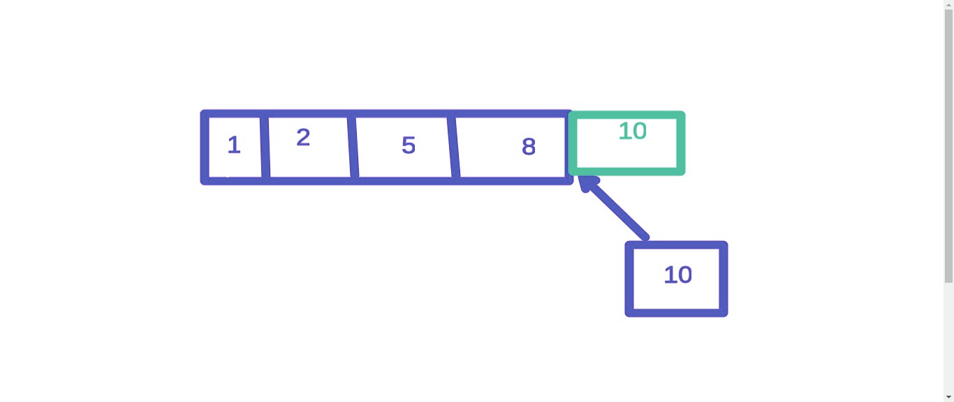

**Syntax:**

| vec.push_back(value); |
| --- |

**Time complexity:**

O(1)

**Eg. 1 A code using push_back():**

| #include <bits/stdc++.h> using namespace std;  int32_t main() {  vector<int> vec(3, 8);  vec.push_back(22);   int n=vec.size();  for(int i=0; i<n; i++)  {  cout<<vec[i]<<" ";  }    return 0; } |
| --- |

**Eg. 2 Difference between changing value using vec[i] and push_back():**

| vector<int> vec={2, 3, 4, 6, 9}; |
| --- |

**Case I: (Changing value using vec[i])**

| vec[2]=99; |
| --- |

// New value of vec: { 2, 3, 99, 6, 9}

**Case II: (Inserting element using push_back() )**

| vec.push_back(100); |
| --- |

// New value of vec: { 2, 3, 4, 6, 9, 100);

**.resize()**

Resize the vector to a different size

Eg.

| vec.resize(100); |
| --- |

// Make the size of vector 100

**.sort()**

// Used to arrange all elements of vector in increasing or ascending order

// O(N log N)

| sort(vec.begin(), vec.end()); |
| --- |

**.reverse()**

// Used to reverse a vector

// O(N)

| reverse(vec.begin(), vec.end()); |
| --- |

**Q.** Suppose, the input format is given like this:

All elements are given as space separated integers and last element is -1. Write program to take input of these integers.

| int num=100; vector<int> vec; while(num != -1) {  cin>>num;  vec.push_back(num); } |
| --- |

**For auto loop to print all elements:**

| for(auto num: vec) {  cout<<num<<" "; } |
| --- |

Note: But using this syntax, you can can’t change any value of the original array. (Similar to call by value)

**If you want to change all the elements of the array**, use reference variable by **putting & sign before variable name** in loop (Similar to call by reference)

**Example**

| for(auto &num: vec) {  num=100; } |
| --- |